**Fractionation by Sequential Detergent extraction**

**Main protocol**

**Stock solutions**

* 1% (w/v) digitonin (Calbiochem; Cat. no. 300410) in DMSO
  + (freeze in 100 ml aliquots).
  + Digitonin stock solutions are unstable to long-term storage. We recommend making up small volumes of stock solution and discarding at monthly intervals.
* RNaseOut™ Recombinant Ribonuclease Inhibitor: 40 U/ml stock. Store at −20°C (Invitrogen; Cat. no. 17-0969-01).
* 3. Complete™ Protease Inhibitor Cocktail: Complete™ EDTAfree (Roche Molecular Biochemicals; Cat. no. 1-873-580).
  + Make a 100× stock in DMSO and store at −20°C. Use at a final concentration of 1×.
* Diethyl pyrocarbonate (DEPC)-treated water. Prepare as a 0.1% (v/v) solution and incubate at 37°C overnight. Autoclave for 15 min to destroy unreacted DEPC.
  + DEPC is a suspected carcinogen. Avoid inhalation and skin contact and always handle in a fume hood. However, after autoclaving, DEPC-containing solutions are no longer reactive or hazardous, though they have a slightly sweet odor
  + Reagents and buffers are dissolved/prepared with DEPC-treated water unless stated otherwise
* 4 M potassium acetate (KOAc)
* 1 M potassium 4-(2-hydroxyethyl)-1-piperazineethanesulfonate (K-HEPES)
* 1 M magnesium acetate [Mg(OAc)2]
* 0.2 M ethyleneglycol bis (2-aminoethylether)-N,N,N ¢,N ¢–tetraacetic acid (EGTA) at pH 8.0;
* 10% (v/v) Nonidet P-40 (NP-40)
* 10% (w/v) sodium deoxycholate (DOC)

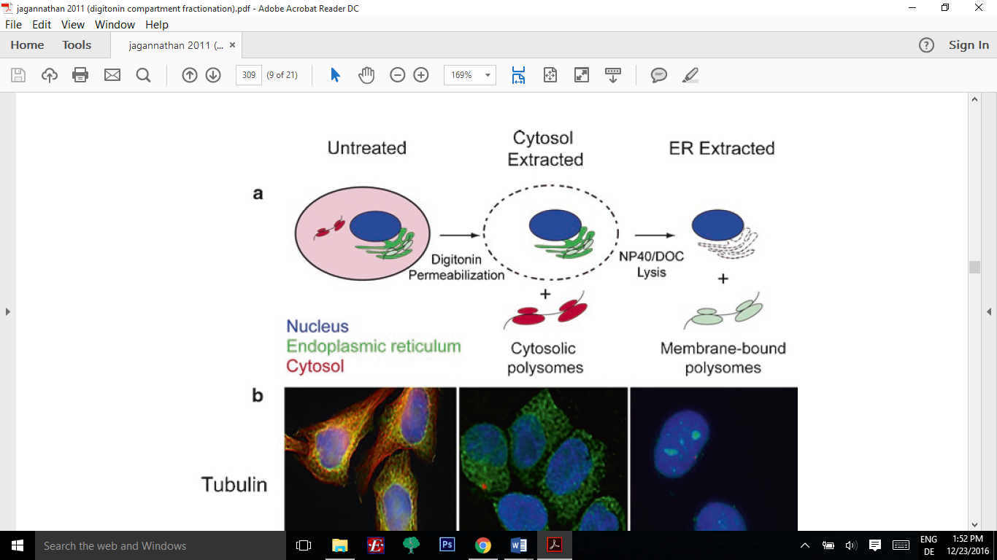

* Add fresh media to cells in 100mm plate 1 hour before the start of the experiment
* (optional: add warm media with 100μg/ml cycloheximide for 10 min. at 37°C)
* Aspirate the media and wash the cells once with 10 ml of 1×PBS (room temperature)
* Treat the cells with 10 ml of ice-cold PBS (1×) containing 50 mg/ml CHX for 20 min on ice (put at 4°C).
* Add 1 ml of ice-cold permeabilization buffer to the cells and incubate on ice for 10 minutes and collect cytosolic fraction in 1.5 ml Eppendorf on ice.
  + Permeabilization buffer: 110 mM KOAc, 25 mM K-HEPES, pH 7.2, 2.5 mM Mg(OAc)2, 1 mM EGTA, 0.03% digitonin, 1 mM DTT, 100 mg/ml cycloheximide (CHX), 1× Complete Protease Inhibitor Cocktail, and 40 U/mL RNaseOUT™. Digitonin, DTT, CHX, Complete Protease Inhibitor Cocktail, and RNaseOUT™ must be added fresh.
* Wash cells gently with 1 ml of ice-cold wash buffer
  + Wash buffer: 110 mM KOAc, 25 mM K-HEPES at pH 7.2, 2.5 mM Mg(OAc)2, 1 mM EGTA, 0.004% digitonin, 1 mM DTT, and 50 mg/ml CHX. Digitonin, DTT and CHX must be added fresh.
* Treat the cells with 1 ml of lysis buffer for 10 min (at RT since DOC precipitates at 4°C). Drain and collect the soluble material (membrane fraction)
  + Lysis buffer: 400 mM KOAc, 25 mM K-HEPES at pH 7.2, 15 mM Mg(OAc)2, 1 mM DTT, 50 mg/ml CHX, 1× Complete Protease Inhibitor Cocktail, and 40 U/mL RNase Out with 1% (v/v) nonidet P-40 (NP-40) and 0.5% sodium deoxycholate (DOC) (w/v). DTT, CHX, Complete Protease Inhibitor Cocktail and RNaseOUT™ must be added fresh.
* Clarify both the cytosolic and membrane fractions by centrifugation at 1000xg (3200 rpm in the small centrifuge) for 10min at 4°C:
* Centrifuge at 7500xg (8900rpm in small centrifuge) for 10 min at 4°C
* Samples are ready to Freeze at -80°C for storage or use in downstream experiments (polysome profiling, RNAseq/ribosome profiling, Western blot etc.)
  + *RNAseq/ribosome profiling*: extract RNA from fractions using 1 ml TRIzol® Reagent per 0.25 ml of sample (see Subheading 3.4). Samples in TRIzol® can be frozen at −70°C for storage prior to processing.
  + For more information on how to proceed with downstream application, see:
    - Jagannathan, Sujatha, Christine Nwosu, and Christopher V. Nicchitta. "Analyzing mRNA localization to the endoplasmic reticulum via cell fractionation." RNA Detection and Visualization: Methods and Protocols (2011): 301-321.

**Modifications to protocol when downstream experiment is IF**

* Seed cells 24 well plate containing 12mm glass coverslips 1 day before.
* Add fresh media to cells 1 hour before the start of the experiment
* Aspirate the media and wash the cells once with 0.5 ml of 1×PBS (room temperature)
* Treat the cells with 0.5 ml of ice-cold PBS (1×) containing 50 mg/ml CHX for 20 min on ice (put at 4°C).
* Add 200 μl of ice-cold permeabilization buffer to the cells and incubate on ice for 10 minutes.
* Wash cells gently with 200 μl of ice-cold wash buffer
* Treat the cells with 200 μl of lysis buffer for 10 min (at RT since DOC precipitates at 4°C). remove buffer and remove membrane fraction
* Wash 1x with ice-cold PBS
* Fix with 3-4% PFA for 10 minutes at RT
* Incubate coverslips with staining buffer (SB, 0.05% saponin, 10 mM glycine, 5% FBS, and PBS) for 15 min at RT.
* Aspirate SB and incubate coverslips with primary antibody diluted 1:100 in 100 μl SB on rocker
  + Against tubuline to visualize the extraction of the cytosolic fraction
  + Against Trap-α to visualize the extraction of the membrane/ER fraction
* Aspirate primary antibody and wash coverslips X 1 with PBS.
* Incubate coverslips with secondary antibody diluted in SB for 1 h on rocker protected from light
* Aspirate secondary and wash coverslips X 3 with PBS, leaving in last wash
* Mount coverslips to glass slides with Prolong gold anti-fade reagent + dapi (6ul for a 12mm coverslip). Allow coverslips to cure overnight before imaging. Store slides in dark.

**Relevant publications**

* Jagannathan, Sujatha, Christine Nwosu, and Christopher V. Nicchitta. "Analyzing mRNA localization to the endoplasmic reticulum via cell fractionation." RNA Detection and Visualization: Methods and Protocols (2011): 301-321.
* Jagannathan, Sujatha, et al. "De novo translation initiation on membrane-bound ribosomes as a mechanism for localization of cytosolic protein mRNAs to the endoplasmic reticulum." Rna 20.10 (2014): 1489-1498.
* Stephens, Samuel B., et al. "Stable ribosome binding to the endoplasmic reticulum enables compartment-specific regulation of mRNA translation." Molecular biology of the cell 16.12 (2005): 5819-5831.
* LERNER, RACHEL S., et al. "Partitioning and translation of mRNAs encoding soluble proteins on membrane-bound ribosomes." Rna 9.9 (2003): 1123-1137.